
Banff Academy – local language skills. Staff edition.
Your words, what they mean and where they’re from.
Yer ain wirds, fit they mean an far they’re fae.

Compiled by Dr Fairbairn and the Scots Language Classes. With thanks to everyone who took part.
Sources: Concise Scots Dictionary (2017); Buchan and Toulmin (1989) Buchan Claik; Douglas Kynoch (1996): A Doric dictionary.

History: Many of the Scots words you have in your heads are up to 600 years old. These Scots words were part of the language of the courts, famous and learned literature, and the law. They were spoken by Kings and Queens as well as loons and quines. Somehow, against all odds, they have survived, from their early beginnings in the Norse peppered Saxon of Northumberland, through Inglis and then Scottis as they moved north and changed over time. They are the magic dust from Medieval times, which still sparkle in the corridors and classrooms of Banff Academy and the wider community. |  | Foo muckle do you ken?  1. If you fancied some custard with your rhubarb crumble, would you have a pickie, a pucklie or a suppie?  2. If you were hammering together some lengths of wood to create a new kennel for the dog, would you need a suppie nails, a pickie nails or a pucklie nails?  3. If you wanted to perk up a dreary plate of stovies, would you add a pickie paprika, a pucklie paprika or a suppie paprika?  Read on to find out!
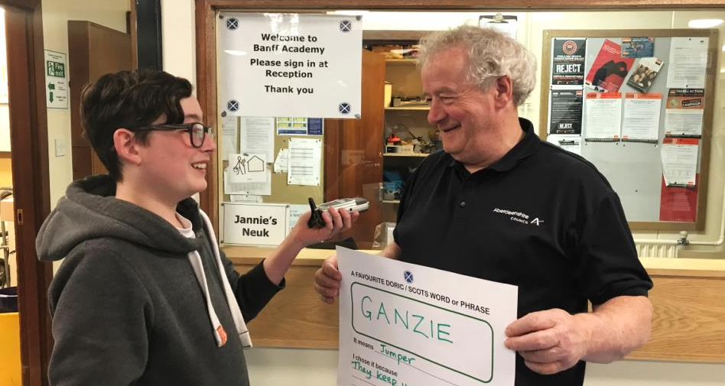 | 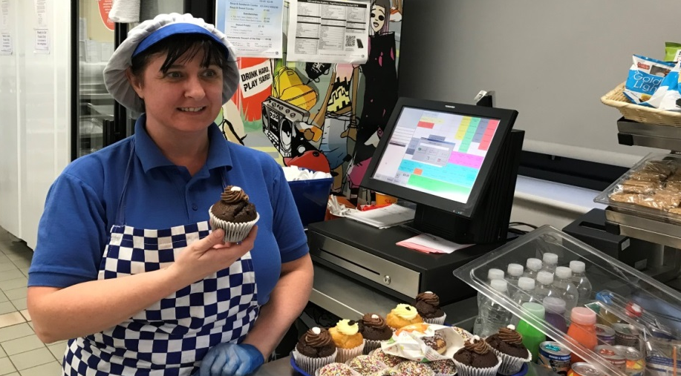  Photos: Claire Needler

Staff | WORD | Means to me | Why I like it | Dictionary definition / comments
Mrs McQuaker  Drama | Bairn | Child or baby | It’s used in a play I love called Men Should Weep by Ena Lamont Stewart. | A child, baby, infant. Old Norse Barn
Mrs Bishop  Lifestyle | Black Affrontit | Embarrassed | I use these words fairly regularly in my day to day speech. | Ashamed or deeply embarrassed, from Old French Affronter
Mrs Paterson | Blether | A long chat or a chatterbox | My friends and family tell me I’m a blether | To talk foolishly or in a trivial way; to prattle, speak boastfully; a chatterbox, from Old Norse blaðra – to utter inarticulately, move the tongue to and fro
Mrs Herdman | Bosie | Hug or cuddle | It is a POSITIVE word – we all need a bosy from time to time | To cuddle. NE Scots, reduced form of bosom.
Mrs McAlister | Bosie | Hug | It’s a warm and friendly word that makes me smile | To cuddle. NE Scots, reduced form of bosom.
Miss Steven | Whit a Bourach! | What a muddle, mess, disorganised heap | I think the sound of it expresses its meaning perfectly | A crowd, group, cluster. A disorderly heap or mess. A muddle, a mess, a state of confusion. Probably from Gaelic, búrach a mess or shambles.  Alternative spellings boorach, bourach, bourock
Mr Watson | Bourack | A mess | It reminds me of my classroom
Mr Kilpatrick | Breenge | Lunge, charge, barge | I have often been described as a breenger in relation to me DIY skills. | A violent or clumsy rush, a dash, a plunge; to barge forward recklessly. Unknown origin.
Mr D’Everlange | Coo | Cow | It reminds me of the French word COU, meaning neck | A cow. Related word Kye. Cows are also known as Nowt and beasts in the North East. From Old English Kú. Pronounced as in Scots in Germanic languages such as Norwegian and German.
Mrs Chalmers | Couthy | Warm and friendly | It sounds cosy and comforting. You can feel relaxed and accepted if you are with someone who is couthy. | Of people: agreeable, sociable, friendly, sympathetic. Of places or things: comfortable, snug, neat. Compare with Old English cuði, known, familiar.Eth uppercase: Ð, lowercase: ð; also spelled edh or eð) is a letter used in Old English, Middle English, Icelandic, Faroese (in which it is called edd), and Elfdalian. It was also used in Scandinavia during the Middle Ages but was subsequently replaced with dh and later d.
Staff | WORD | Means to me | Why I like it | Dictionary definition / comments
Ms Newbould | Cowpit Yow  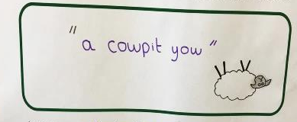 | A female sheep which has fallen over onto its back and is finding it difficult to get back on her feet. Or figuratively someone who is extremely drunk | I like the IMAGERY of the phrase. Also being pregnant I sometimes feel like a cowpit yow in my bed!  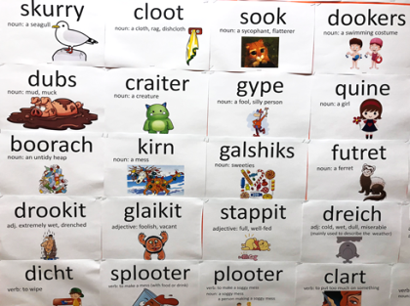 | To cowp is to overturn, upset or ruin; to overbalance, fall over or capsize or become bankrupt.  COWPY. A sheep that has overturned on its back and is unable to get up.  From Old French, couper, to strike.
Mrs Mair | Cyaav | To fuss | I like the sound of it and it sums up some kinds of fussing much better than an English word! | In the same way as SNYAAV is a form of SNAA or snow – an old form, still used in some settlements along the coast and inland on the farms, CYAAV
Odette Strain | Dookers | Swimwear | Good word | A swimming costume. To dook, the act of ducking or diving; a bathe, a swim; to dip or immerse. From Middle Dutch and Middle Low German duken.
Mrs Mair | Dreich | Cold, dreary or otherwise miserable – usually referring to weather | It is a unique word that really describes some Scottish weather. English just does not come close to describing it. | Of weather or scenery – dreary, bleak. Also extensive, persistent, tiresome, hard to bear. Of people, depressed, doleful, dull, boring. Of tasks, difficult.  From Old Norse drjúgr – enduring, ample.
Mrs Murray | Dreich | Dreary or bleak | It is very descriptive and often describes our weather.
Carol Park | Drookit | To be soaked | I hate being drookit in the rain and I love the sound of the word. | Drenched, soaked. Compare with Old Norse drukna, to be drowned.
Mrs Slater | Drookit | Soaking wet | Common saying ‘like a drookit rat’
Mr Milne | Eejit | Plonker | I am often an eejit and it sounds brilliant | Idiot, fool, stupid person. From Middle English Idiot.
Staff | WORD | Means to me | Why I like it | Dictionary definition / comments
Mrs Hadden | The 5 Fs  Fa?  Fit?  Fit wye?  Far?  Fan? | The 5 Ws:  Who?  What?  Why?  Where?  When? | Doric grammar  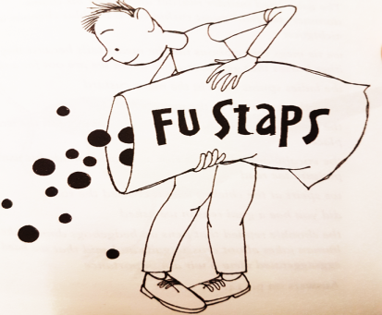 | The Doric form of wh is f, as in Fitehills, or a quartz rock in Fitehills called the Fite Coo. This is unique to North East Scots.  The story goes that in a North East shoe shop the question “Which foot fits which foot?” is more likely to be “Fit fit fits fit fit?”
Miss Hepburn (Lifestyle) | Fit Like? | How are you? | Aye, aye min, fit like the day? Nae bad! Chosen because it’s confusing to those outwith the North East. | How are you? In Orkney a similar greeting is used, but with wh-: Whit like? From Old English hwaet.
Miss Owen | Fly Cup | Having a break and a cup of tea or coffee. | It was the phrase that everybody found really funny when I was living in Bahrain, and I ended up having to explain what it meant over and over again! | A quick or surreptitious cup of tea. From Scots Fly meaning shrewd + cup.
Mrs Farquhar, ASL | Foggie Bummer | A bumble bee | It’s very descriptive and you can’t help but smile when you say it. | Foggie Bummer – a bumble bee. Also Foggie Toddler, immortalised in a William Soutar ( the Perth Poet) poem.
Mrs Fulton | Foonert | Tired, exhausted | That’s how I feel before the holidays. | Foonert or foundert: in a state of collapse, exhausted, overcome by cold. Origin Middle English foundren.
Mr McClymont | Foonert | Weary, tired out, knackered. | Ah aiways feel foonert! Ah’m foonert when ah wake up, foonert when ah’m at skeel, an foonert when ah gan hame.
Dr McCabe’s daughter Martha | Foostie | Rotten or off | It sounds funny! | Foostie, fousty, fooshtie, fooshty. Stale, musty, mouldy. From Old French foust.Old Scots foistit.
Staff | WORD | Means to me | Why I like it | Dictionary definition / comments
Yvonne Knowlson | Furri boots ya gan? | Where are you going? |  | A form of Far aboots ye gaan?  Furry Boots City is a jocular name for Aberdeen, emerging in the 1990s.
Wendy Jones | Futret | Ferret | I have 5 of them!  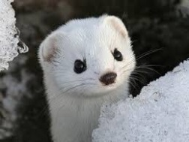 | Also futrat, whitret. An animal of the genus Mustela, mainly the weasel, stoat or ferret. A small, thin, sharp featured person. A restless or furtive person. From Middle English, Middle Scots whitrat – a white rat.  Immortalised in Scotland the What’s Ballater Toy Shop sketch.  https://www.youtube.com/watch?v=NzS3AdzZ0Nw
Jannie’s Neuk | Ganzie | Jumper | They keep you warm! If you put yer airms in the air you can rax yer ganzie. Anither word is Maazie, as in ‘she wis wyvin a maazie’ (knitting a sweater). | Gansey, ganzie. A Guernsey, a jersey, especially one worn by a fisherman.  The word is now used as an everyday word for any kind of sweater.
Mrs Maison | Gan Aboot Hens | Free Range Chicken | Childhood memories on the farm looking to see where the hens had laid their eggs. | Going about. From Old Norse gangr, Old English gang.  One of a few new Doric words for modern things, e.g. a sitootery, for a conservatory
Miss Cherry | Glaikit | Stupid, foolish, thoughtless | I Went to school in Huntly, some teachers often said ‘dinna jist sit there lookin glaikit’, when I was day-dreaming. | Also Gleekit. Foolish, stupid, thoughtless, irresponsible. First refered to in the 1500s.  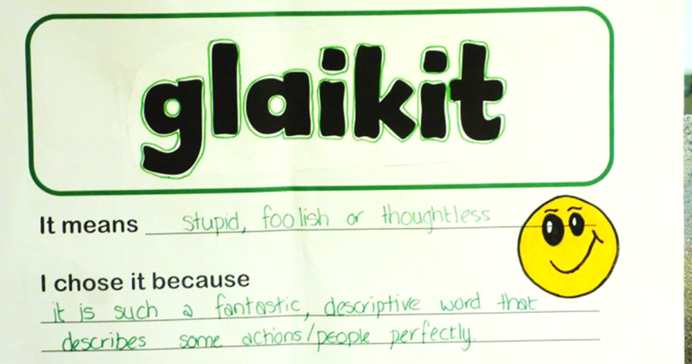
Mrs Howitt | Glaikit | Stupid, foolish or thoughtless. | It is such a fantastic, descriptive word that describes some actions / people perfectly.
Mrs Thompson | Glaikit | Daft or foolish | It is such a good word to say out loud and it is so descriptive.
Staff | WORD | Means to me | Why I like it | Dictionary definition / comments
Mrs Farquhar | Gutties | Trainers | Not many people know what it means. | Guttie. Something made wholly or partly of rubber. Gym shoes. A guttie ba is a golf ball. From the Malay getah, meaning gum.
Miss Bowie Lifestyle | Halliracket | Crazy or Wild | I always laugh when I hear people use the word. | Halliracket, hallyracket. Frivolous, crazy, boisterous.  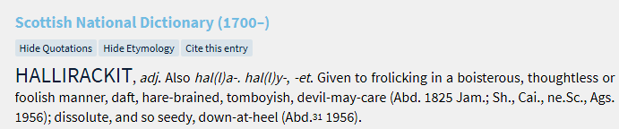
Mrs O’Reilly | Halliracket | Loud, daft, boisterous | It is a great sounding word! There is no other word like it in English.
Mrs Hazlehurst | Hallyracket | Hare-brained, foolish, devil-may-care. | I like the way it sounds when spoken
Dr McCabe | Haver | Speak nonsense | It’s my hobby! | To talk in a foolish or trivial way, speaking nonsense. To dawdle, potter about, fuss. To make a pretence of being busy. To vacillate.  Haivers! Nonsense! Popular from the Proclaimers song 500 miles.
Ms Adey | ill tricket | Mischievous | I have three ill-tricket grandsons who make me smile | Prone to play tricks, mischievous.  e.g. “A richt ill-tricket cratur, aye up tae something.”
Mr Bappoo | Jings! | Used to express surprise. | My introduction to many Scots words was Oor Wullie. This is one of his favourites. | Gosh! Oor Wullie is the iconic wee Scottish laddie from the fictional town of Auchenshoogle. Wullie loves life, fun and laughter with the help of his lifelong pals Fat Bob, Soapy Soutar, Wee Eck.The full phrase he often uses is Jings! Crivvens! Help ma Boab!
Miss Paton | Jougal | n. also Joogle, a dog. | It’s my favourite Banff word. ‘Luik at that fluffy jougal’.  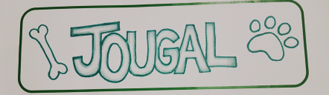 | This word seems at first sight to be unique to Banff. It is known by quite a few adults and bairns around the school. I (Dr F) was taught it by a member of Portsoy Pipe Band, who commented on a handsome dog walking past at a Highland Games, saying “that’s a richt joogle!” The word has its origins in the indigenous traveller community, and has passed over into Banff talk from the traveller secret language – the cant (chant), which also has words like gadgie, cuv, neddies, yarras, whammelin cocavies and stumers. We have pupils and parents who understand these words.
Mrs Nicholson, Library. | Malagaroose | To spoil, injure or hurt. | The sound of the word is more lively than English equivalents. | Also Malagruize, malagroose. To dishevel, disarray or spoil.  ‘Dinna malagarooze it!’ Don’t damage or spoil it.
Staff | WORD | Means to me | Why I like it | Dictionary definition / comments
Mrs Rankin | Maugre | A right mess | I like its sound. | A scots word. As well as this meaning, the word also means ill-will, displeasure, spite. ‘in mauger of’ in spite of.  From Old French maugré.
Ms Hepburn Music | Neep | Turnip | I affa like a bowl o neep and tattie soup fan it’s a cal day outside. | A turnip, a swede. From Old English næp, Latin napus.
Mr Reid | A pairk o Nowt | A field of cows. | We used to visit a family friend living near the Broch. They were all broad speakers and we found them virtually incomprehensible. Spoke about bringin in the Nowt. | Nowt. Cattle. One head of cattle. An Ox or steer. From Old Norse naut.  Finlay the jannie uses this word for cattle or kye, and some pupils too.
Nicola Robertson | Peely-wally | Pale and sickly in appearance | I think it’s quite expressive / descriptive! | Peelie-wally. Sickly, feeble, pallid, thin and ill-looking. Also peelie-wersh. Original probably an imitation of a whining feeble sound.
Miss Murdoch | Peelie-wally | Pale, unwell, under the weather | It’s a phrase I would use more regularly than most others
Miss MacFarlane, Science | Piece | Sandwich.  (A sandwich in many parts of Scotland, but in Banff a biscuit or a cake if a fine piece, or even better if a funcy piece!) | I’m (not) a sky-scraper wean!  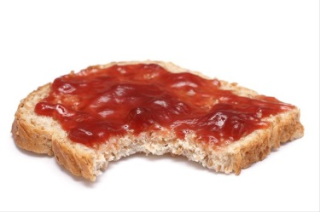 | This refers to The Jeely Piece song, by Adam McNaughton (1967) as a social comment on housing conditions in Glasgow. The first two verses:  I'm a skyscraper wean; I live on the nineteenth flair,  But I'm no' gaun oot tae play ony mair,  'Cause since we moved tae Castlemilk, I'm wastin' away  'Cause I'm getting' wan meal less every day:  Oh ye cannae fling pieces oot a twenty story flat,  Seven hundred hungry weans will testify to that.  If it's butter, cheese or jeely, if the breid is plain or pan,  The odds against it reaching earth are ninety-nine tae wan.
Mr Aitken | Pleiter | Splash or wade aimlessly | It was the first Doric word I learned in the novel Sunset Song. The sound of it is fantastic. | Pleiter or plowter. Dable with the hands or feet, usually in a liquid, splash aimlessly in mud or water, wade messily through wet ground. Compare with Dutch ploetern, dabble in water.
Staff | WORD | Means | Why I like it | Dictionary definition / comments
Irene Smith | Pucklie | A small amount | It fits the meaning. | Pucklie. Collective noun. A small number of individual items. Pronounced exactly as it looks.  Thus, you would pour “a suppie watter on a pucklie tatties and bile them up for yer denner“. Of course, you would need “a pickie saat” (a pinch of salt) in your tatties.
Ms Steele Maths | Quine | girl | It was the first word I learned when I moved up to Aberdeenshire | A young woman, a girl. A female child, a schoolgirl. Origin: Old English cwene a woman, wife, mistress or queen. Compare with Norwegian Kvinne, woman.
Mr Henderson, library | Sclab Dabber | A generous portion | I like the sound of it and I prefer a good sized portion in a restaurant!
Miss Mackie | Scutter | A nuisance | I like how the word sounds | Messy or difficult work; a nuisance. To scutter aboot – to mess about.  In other parts of Scotland meaning is subtley different: to do something in a slovenly or bungling way, make a mess of; to spill or splash about; a time-consuming or irritating occupation.
Dr Taylor | Shooglie / shoogly | Wobbly | I like the sound. Good classroom word. Shoogly desks and chairs; shoogly ideas. | Shaky, unsteady, tottery, insecure.  e.g. yer jaicket’s on a shooglie peg – you are in a precarious position, you are likely to lose your job.  Middle English shoggen, compare Low Mid German schocken.
Ms Massie | Skitter | A right mess! | I like saying the word, it has real meaning when you emphasise the K. | Anything dirty or disgusting, a mess, rubbish. Also skitter – trifling, small, inadequate. Of course it also means diarrhoea.  From Old Norse skýt, stem of skyóta – to shoot, propel, dart.
Mr Harris | Smirr | Mist-like precipitation | It is a great type of weather to go running in. Very refreshing and keeps you cool. | Fine rain, drizzle; sometimes fine sleet or snow. A smirr o rain – fine rain, drizzle. Perhaps onomatopoeic.  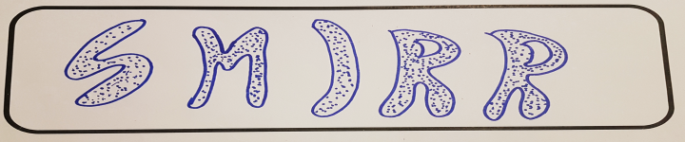
Miss Grant | Sotter | A mess | I don’t want my room to be left in a sotter when pupils leave! | A mess, a muddle, a confused mass, chaos; the noise made by something boiling, fying or bubbling up.
Mrs Hendry | Sotter | A mess | I’m not comfortable when areas are untidy or disorganised.
Staff | WORD | Means | Why I like it | Dictionary definition / comments
Mme Pantel | Fit a Sotter! | What a mess!! | I spend my life tidying up everyone else’s mess!! | Compare with German dialect sottern.
Mrs Neale | Speir | Ask | I like the sound of it and the idea of poking / spiering folk for answers! | To ask a question, inquire, make inquiries; to seek out an opinion, Speir at – to put a question to  Speir efter – to inquire about a person or a thing.  From Old English spyrian; compare with Norwegian spørre – to ask.
Karen Smith | Spikin | speaking | Everyone needs to speak to someone at some point – It’s good to talk! | Also spikkin. From Old English spæc
Mr Horberry | Stotter | Beautiful person | My three daughters are wee stotters.  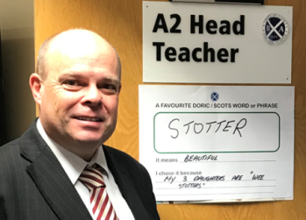 | Stotter, or stoater. A term of admiration, mainly for females; an excellent example.  Stot is to stop, bring to a halt, pause, hesitate. So stotter means someone who brings you to a halt due to their attractiveness.  From Middle Dutch, Middle Lower German stōten.
Mrs Tait | Strushle | Untidy or messy | One of the words I learned when I came up to the area. It’s unusual, too. | Untidy, slovenly, disorderly. A strush can also be a disturbance, squabble; a commotion. Probably onomatopoeic.
Dr Fairbairn | Thraan, thrawn | Willfully, perversely stubborn | I know a few folk like that, and there isn’t an English word that on its own describes that type of person so well. | Thrawn. Perverse, obstinate, intractable, sullen, surly. Twisted, crooked, distorted.  Of string or thread fashioned from strands twisted together.  From Old English ðrāwan.
Ms Strachan | Thrapple | throat | I like the sound it makes and it reminds me o ma mither. “A thrush wi a speckled thrapple”. | The windpipe, the throat, the gullet. From the 1400s.
Miss MacCall, English | Vratch | Nuisance (yer a wee vratch) | My gran (whom I love dearly) regularly calls me with this in fondness. It’s also a really fun word to say. | Vratch. A despicable person capable of vile, wicked behaviour. From Old English/ Scottis wrecca, wræcca an exile.  Examples:  “He telt me a hillock o lees, the vratch.” (He told me a heap of lies, the wretch.
Staff | WORD | Means to me | Why I like it | Dictionary definition / comments
Miss Johnston | Haud yer Wheesht! | Be quiet! | Just love it! | Be quiet, shut up!, hush. From the late 1600s.  Probably Onomatpoeic.  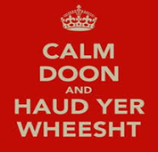
Mr O’Reilly | Hold your Whist! | Be Quiet! | It is an Irish version of a Doric word.
Mrs McFarlane, Creative | Wifie | A female adult (informal) | It is the only Doric / Scots I have embedded into my own speech as it seems less offensive than the Glaswegian Wee Wummin (Also Scots). | Woman. An old fashioned little girl. A diminuation of wife.  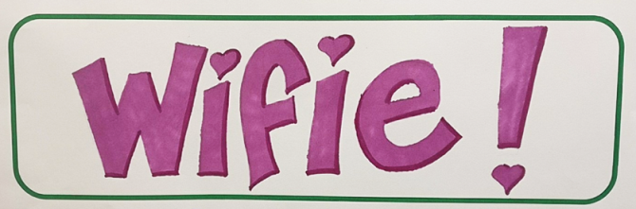

Hope ye aa enjoyed yer ain words. Keep usin them! Dinna let them dee.
Historical Note. From the Banff Academy records, Annals of Banff, 1704. Patrick Leslie objects to the appointment of Patrick Morrison as a teacher, or dominie. Luckily, this sort of nonsense doesn’t happen any more…
'because there is noe order or method keept either within or withoot the schooll, the schollers bein incuradged to swearin and drinkin and vther inormityes partlye by the Maister's neglect to chastise them and partly by evill exemple'..also being 'a habituall drunkard and cairder and speciallie it is offered tae be proven that he went in with ane caball of his ain tae the hoose of Ballyie Wallace at sevin alcloack at nicht and drank and played at cairds all that nicht until sevin acloack nixt mornein'.

Ordiquhill – a poem by Katie McKay  My hometoon is a bonnie place  It ayeways brings a smile tae my face  Ordiquhill is a place o grace.  The timber smells o fresh pine  The smells tak ye back tae yer childhood  A time fan everything wis peaceful and fine.  Ancient buildings fae years ago,  Guairded by dragons,  Sae fierce.  But watch yer solemn, danderin feet  for the number o different creatures that roam.  The rollin hills  wi sheep, coos and goats  mak a bonnie sicht tae see.  Ordiquhill will forever be in ma hairt  Wi its silent forest walks and its bonnie sichts  Ye'll lose time in Ordiquhill  Starin at the nicht sky.  In yer ain wee bubble  Silently watchin the sun set  Ower the Knockhill.  Both pieces published at http://skoosh.scotshoose.com | Rich n Peer – a story by Kaydi McArthur  Eence upon a time in a land affa far awa, ere wis an affa fine loonie cad James MacPherson. He bade in Inversneckie bit he floated aboot awye.  The ae hing folk didna like aboot um wis he reeved money and scran ti help aa the peer folk. Aa o the minted gadgies hated um. They didna like their money bein teen awa. Heaps o folk hated his guts bit ithers loved um. He wis ay gettin chased by the bobbies fan he nicked stuff fae the maerkets. Ere wis een manny that wis determined ti catch i loon. At wis Lord Duff o Braco, the loon that bade doon at Duff Hoose in Banff.  So Lord Duff o Braco hid a wee clan o his chums go after James.  James robbed mony maerkets in Aberdeenshire and Moray. Bit, ae day in Keith, James reeved a loaf o breid, three aipples and a bun. At wis i day he caught oot. Lord Duff o Braco's wee gang caught um. They teen um doon ti the dungeons o Banff. They kept um in ere umsel. He wis well lonely, and it wis affa caul. So wi a his time doon in i dungeons he made a wee sang.  It wis cad 'It is caul' and went a wee bit like ess.  "It is caul, It is caul, I canny feel ma taes.  It is caul, It is caul, I've been stuck in here for days."  He wis stuck for a wik afore he got oot. Fan he got oot, he wis telt he wis gan tae dee. They teen um up tae the galla hill. He wis ti be hangit at twelve noon on the 16th o November in the year 1700. Abidy gathert roon. James wis affa annoyed because abidy winted ti see him die.  A reprieve wis bein sent ower fae Macduff bit Lord Duff o Braco got the time changed on i clock so they could hing him earlier. James noticed i time so he teen his fiddle and played anither sang he wrote and en he snapped his fiddle in half ower his knee.  And en he deed on the gallas tree.

