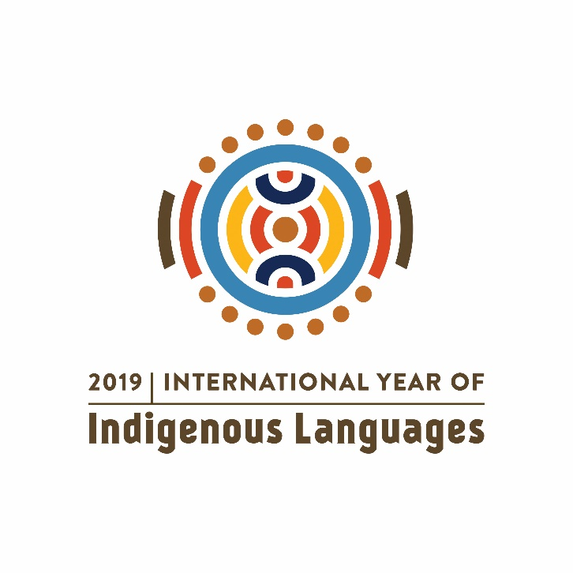

**Results of the Regional Congress of Indigenous Languages for Latin America and the Caribbean, held in the city of Cusco, Peru,  
on 25, 26 and 27 September 2019,  
with the participation of delegations from sixteen countries**

Considering that:

* Language is a fundamental element for the cultural identity and development of peoples and States, and that its loss is not only a loss for its speakers but for all humanity.
* A large number of indigenous languages in Latin America and the Caribbean are in a serious situation and are all under threat.
* Any analysis of the situation of indigenous languages must be comprehensive and must begin by considering the socio-economic, cultural and territorial conditions of the peoples or communities that speak them from a comprehensive approach to human rights and women's rights: without speakers there are no languages.

We propose and commit ourselves to promote the following points:

1. All States at all levels: national, regional and local, are responsible for the promotion, protection, recovery, and revitalization of the indigenous languages of their respective peoples and countries. To this end, they must implement public policies appropriate to the reality of each language and community of speakers.
2. The States commit their efforts to strengthen attention and access to the public services they provide in the indigenous languages of their citizens, in order to guarantee their human rights, particularly their linguistic rights.
3. It is the commitment of all citizens to know, disseminate and promote linguistic rights, encouraging individual and collective exercise by indigenous peoples, and placing the serious situation of indigenous languages and their speakers on the public agenda.
4. This work requires urgent, concerted and coordinated intervention strategies at the national, regional and global levels, with the active participation of indigenous peoples. This action proposes the creation of a regional institution to address the dangers that indigenous languages are facing in Latin America and the Caribbean. We also consider very valuable the elaboration and permanent updating of the UNESCO World Atlas of Languages, with the involvement of universities, research centers, and civil society organizations.
5. These strategies for the recovery and revitalization of indigenous languages must take into account and respect the particularities of languages and their linguistic variants in each zone and region.
6. States should plan and implement strategies, projects, and programmes aimed at ensuring favorable conditions that strengthen and restore the dynamics of intergenerational transmission of indigenous languages, paying attention also to transboundary languages and those spoken in more than one State.
7. We recognize that the responsibility for the recovery and revitalization of indigenous languages is not solely attributable to States, but involves societies as a whole.We,therefore, consider it necessary to highlight the irreplaceable role of speakers, families, civil society organizations, the private sector, and other social actors. Immersion contexts should be promoted for the learning of indigenous languages that, managed by the communities themselves, promote intergenerational transmission and cultural and linguistic revitalization.
8. States and societies must confront linguistic discrimination in all its forms and increase positive recognition of the linguistic and cultural diversity of our peoples by strengthening multilingualism and interculturality.
9. States must recognize and protect the ancestral knowledge and know-how of indigenous peoples, as well as their contribution to humanity and their key role in defending and protecting biodiversity, particularly in the critical context of climate change and its threats to all forms of life on the planet.
10. In the current situation, we see new technologies as a valuable opportunity for the use, development, dissemination, and revitalization of indigenous languages, and for the creation of digital communities of speakers in the diaspora. We,therefore, propose to promote their development and replicate experiences, with special emphasis on young people, women, persons with disabilities and socially vulnerable persons, in addition to incorporating their use in the teaching and learning of indigenous languages.
11. The role of schools in language strengthening and development processes should be reviewed, understanding that revitalization processes should be developed and sustained in spaces outside the school. However, it is reaffirmed that Intercultural Bilingual Education must continue to be implemented in order to close the gap between the two cultures.
12. Finally, the representatives of Latin America and the Caribbean call upon their States to propose to the United Nations the declaration of the Decade of Indigenous Languages as a necessary period to undertake and strengthen the urgent actions that nations and peoples throughout the world have proposed throughout the 2019 International Year of Indigenous Languages.